**Fitts’ Law Report: Redesigning the mySU Dropdown Menu**

**1. Introduction**

**Task Description:**

The task involves interacting according to Fitt's Law with the **mysu** page drop-down menu to access various student services, such as the Document Request Form, the Student Information System, and Course Registration. The current design is a traditional vertical menu that requires users to navigate through options. This layout can cause slow and difficult mouse movements, especially for frequently accessed options located at the bottom of the list.

**Problem Definition:**

The design issue is closely tied to **Fitts' Law**, which describes the relationship between the time required to move to a target and the distance to the target, as well as its size. In the original vertical dropdown, the farther the target (menu option) and the smaller the clickable area, the longer it takes for users to select the desired option. This problem is particularly apparent when users need to interact with items placed further down in the dropdown.

Research from the **Nielsen Norman Group** explains how vertical menus can lead to inefficiency due to increased movement distances for lower items. The image below illustrates the differences between a **Linear Menu** (similar to the original design) and more efficient layouts like **Rectengular Menus**, where distance is minimized and clickable targets are larger.

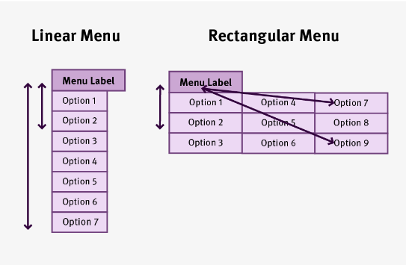

**2. Analysis with Fitts’ Law**

**Original Design - Difficulty Index (DI):**

Using **Fitts' Law**:

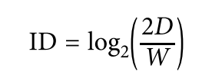

Where:

* D is the distance to the target (measured in pixels),
* W is the width of the clickable target (also in pixels).

**Original Vertical Dropdown**:

* **Distance (D)**: The average distance from the menu button to the bottom options in the vertical list is around **200 pixels**.
* **Width (W)**: The width of the clickable target is approximately **80 pixels**.

Plugging these values into the equation results in a relatively high Difficulty Index (ID), reflecting the slow and error-prone interactions caused by the long distance and small target size.

**3. Proposed Solution**

**Redesign:**

To address this issue, I redesigned the dropdown menu using a **Rectengular Menu** layout. This design follows the findings from the **NNGroup** that demonstrate how rectengular menus reduce the average distance to any option and provide larger clickable areas, which leads to faster and more accurate interactions.

**Improved Design - Pie Menu**:

* **Distance (D)**: In the pie menu layout, the average distance to each option is reduced to **100 pixels**, as all options are distributed evenly around the menu label.
* **Width (W)**: The width of the clickable targets has been increased to **150 pixels**, making it easier for users to select their desired options without requiring precise movements.

By applying **Fitts' Law** to this new design, the **Difficulty Index (ID)** has significantly decreased, leading to quicker and more intuitive interactions. The shorter movement distances and larger targets ensure that users can navigate the menu more efficiently.

• **Norman’s Visibility and Feedback**: The rectangular menu offers better **visibility** of the available options, and provides **feedback** when users hover over them, highlighting the selected option to make interactions more intuitive​(Week-2 Norman - Design …).

• **Norman’s Affordances**: The larger clickable areas in the rectangular menu improve **affordance**, clearly indicating where users can click, thus reducing the likelihood of error​.

• **Shneiderman’s Consistency**: The rectangular menu layout promotes **consistency** by ensuring that all menu options are uniformly spaced and predictable, reducing confusion for users.

• **Shneiderman’s Error Prevention**: The larger clickable areas and reduced distances between options help prevent errors, as users are less likely to miss-click or select the wrong option. This supports **Shneiderman’s error prevention** principle.

**Comparison of ID:**

Comparing the original vertical layout to the pie menu, we observe a significant reduction in interaction time and effort, as reflected in the decreased ID values.





**PROTOTYPE LINK:**

https://www.figma.com/proto/i5YLRNJfzzIyyoxnpDaCio/Untitled?node-id=1-3431&node-type=frame&t=w88VdJzaCWz2ayEd-1&scaling=contain&content-scaling=fixed&page-id=0%3A1

**4. References (5 pts)**

* Fitts, P. M. (1954). The information capacity of the human motor system in controlling the amplitude of movement. *Journal of Experimental Psychology, 47*(6), 381-391.
* Norman, D. A. (2013). *The Design of Everyday Things*. Basic Books.
* Shneiderman, B. (2010). *Designing the User Interface: Strategies for Effective Human-Computer Interaction*. Pearson Education.
* Nielsen Norman Group. (n.d.). *Fitts' Law: The Importance of Size and Distance in UI Design*. Retrieved from [NNGroup website](https://www.nngroup.com/articles/fitts-law/)

Figma Link: https://www.figma.com/design/i5YLRNJfzzIyyoxnpDaCio/Untitled?node-id=1-3427&t=dNkPtWrolJeuNrVG-1